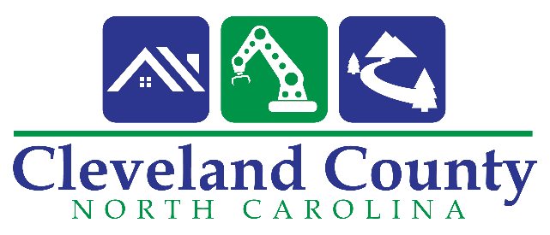

Notice of Public Hearing:

The Cleveland County Board of Commissioners will conduct a public hearing, in accordance with N.C.G.S 153A-77(a). Public input regarding the adoption of a resolution conferring on the Board of Commissioners, all powers, responsibilities, and duties of the Cleveland County Board of Health and transitioning the current Board of Health to an advisory board.

The public hearing will be held in the County Administration Building at 311 E. Marion Street, Shelby NC on Tuesday November 5, 2019 at 6:00 pm in the Commissioners Chamber. At that time the general public will have the opportunity to make comments regarding transitioning the current Board of Health into an advisory board.

Phyllis Nowlen
Clerk to the Board

